Curriculum Vitae.
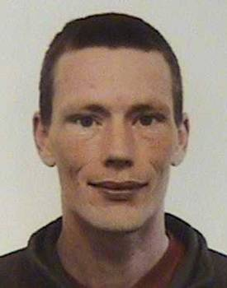
Name: Daniel Cowan.

Address: 14 Landsdowne Place,
Hove,
East Sussex.
BN3 1HG

Tel: 01273 227 593
Mobile: 07740 584 220
Email: dan@danslan.freeserve.co.uk
www.danslan.freeserve.co.uk

Summary
- Experienced programmer specialising in artificial intelligence and evolutionary computing. C, C++, VB and Java used to develop small stand alone applications and embedded control programs.

- Naturally organised and enthusiastic I am trained in clear thinking and systematic analysis. I learn fast and understand my work and its consequences.

- Proven track record in a number of roles, I enjoy the challenge of delivering total quality. I have mature listening skills and offer a calm influence promoting clear communication at all levels.

History
2001-2002: MSc in Evolutionary and Adaptive Systems at the School of Cognitive and Computing Sciences, University of Sussex: extensive AI programming coupled with theory and original research.

1999-2001: General insurance specialist for Global Home Loans (Woolwich/Barclays). Providing sales, support and advice to customers, staff and management in all areas of mortgage related insurance.

1996-1999: First Class Honours in Philosophy from the School of Cognitive and Computing Sciences, University of Sussex.

1988-1996: Self-employed. Running my own businesses to facilitate world travel, I learned a broad range of skills: taking responsibility, thinking on my feet, making decisions and making them count.

Education

MSc. Evolutionary and Adaptive Systems, University of Sussex.
BA Hons. Philosophy, University of Sussex.
4 ‘A’/’A/O’ levels and 9 ‘O’ levels. Kingdown Comprehensive, Warminster, Wilts.

Also….
Single, British subject, born 23 September 1969. Co-founder of Brighton Robotics Society, 2002, keen climber and cyclist. Full driving licence 15 years.

Referees available on request.

